**Test Prep Assessment Guide**

**Voucher Code** : AZ-303-DAA

**Step 1**: Login to the link given below to register for the test prep

<https://testprep.cloudthat.com/login/signup.php>

Fill all the details to register using **Corporate Email address** as shown in the screenshot

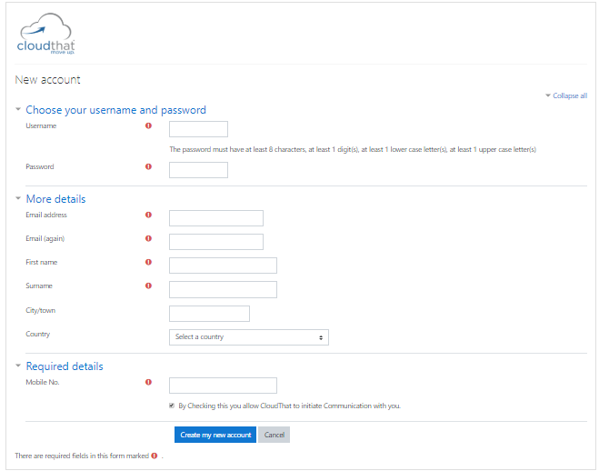

**Step 2**: You’ll land upon home page of the site. Click **My Home** from the panel and fill your details as shown in the screenshot.

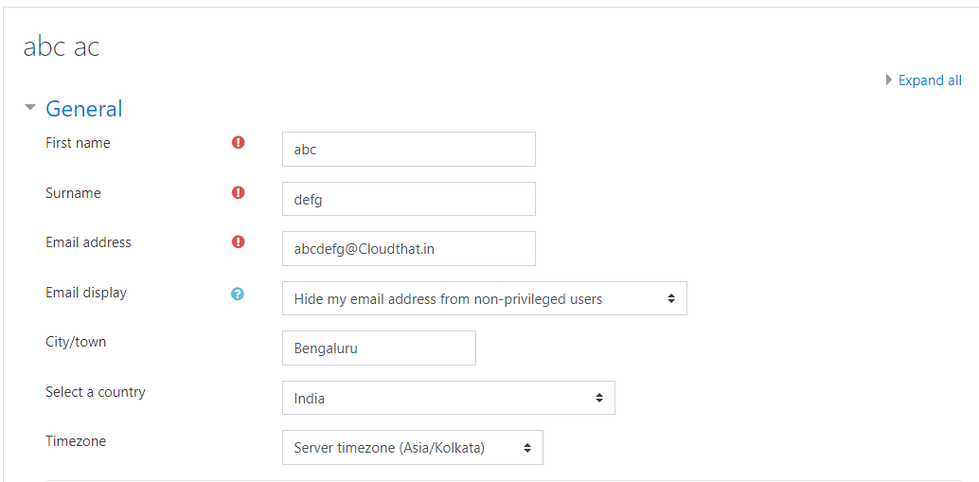

**Step 3**: Click on the Dashboard and in course categories, click on Azure.

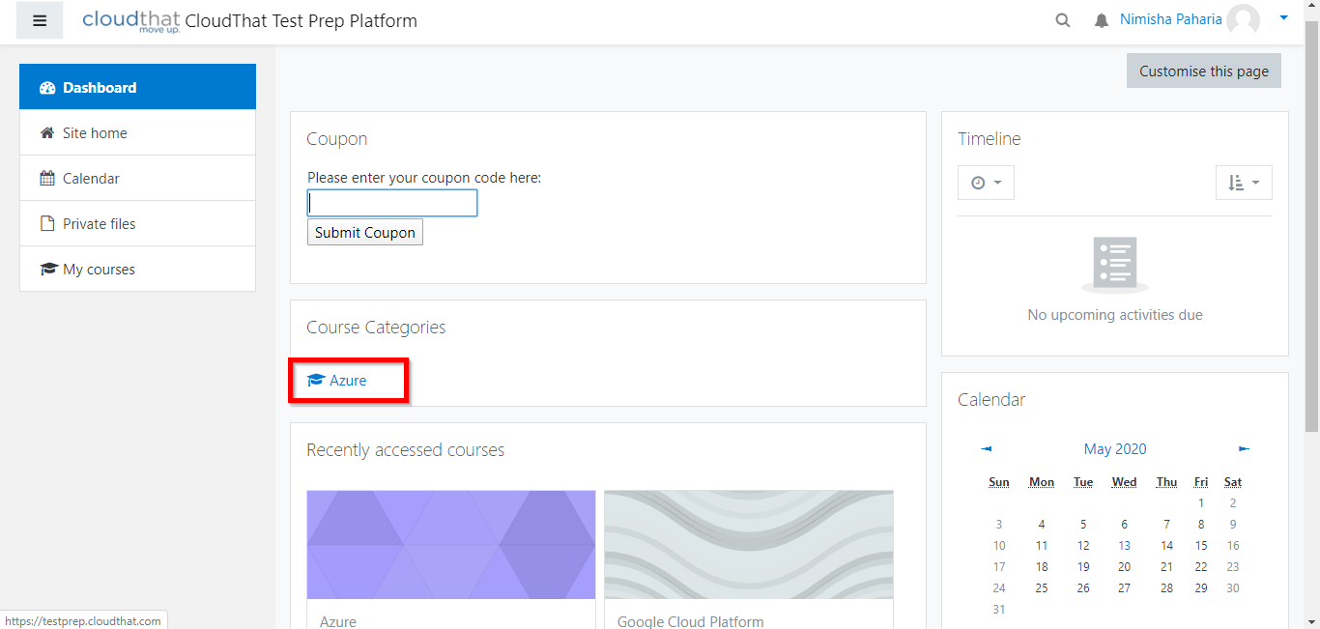

**Step 4:** You will find a list of Azure TestPrep available. Select **Test**

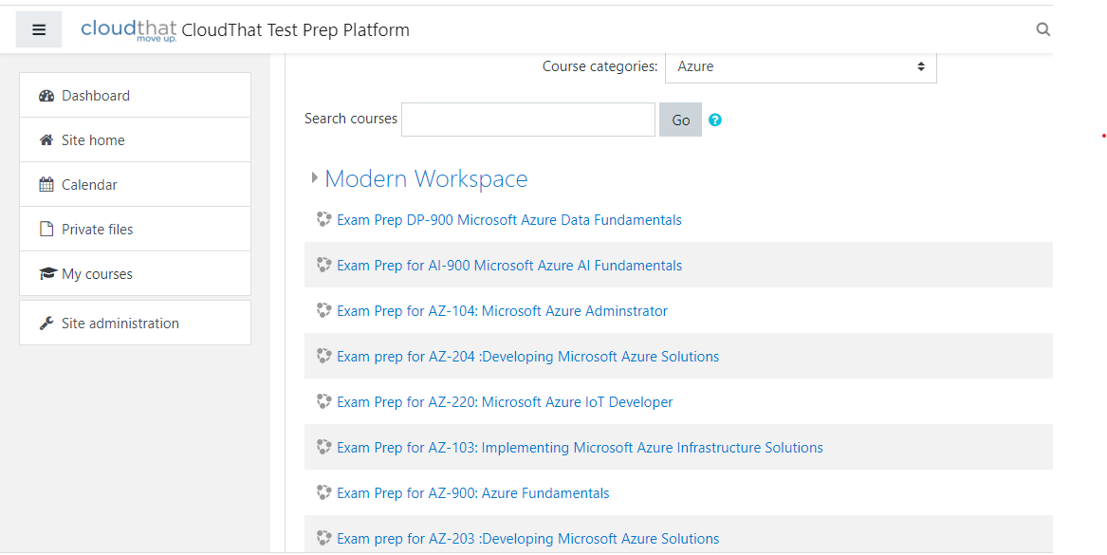

**Step 5**: Paste the Enrolment Key against the AZ-303.

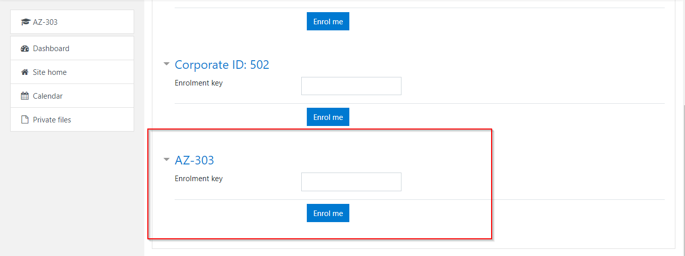

**Step 6**: Upon redeeming the Enrolment Key. Click on the **“Practice”** to attempt the test.

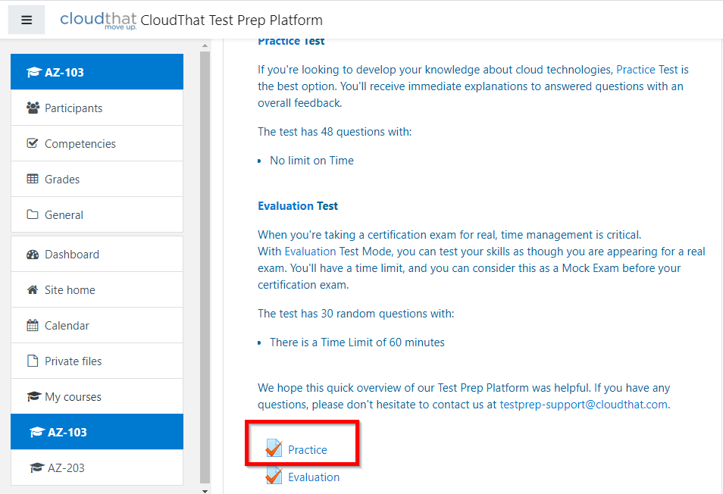

**Notes:**

* Please ensure there is no blank space while pasting the enrolment key.
* There is no limit on the number of attempts per user. However, if you logout and the login again, you will not be able to resume from the same question. You will be able to attempt the next question and answers marked for all the previous questions will be saved for evaluation.
* This assessment does not have a duration.
* At the end of test, you will be able to view your score.
* User must attempt the test within 28 days from the day of enrolment.
* Passing criteria is **70%**. Exam vouchers will be provided to participants who passed the test.

In case of any issue, please reach out to: [testprep-support@cloudthat.com](mailto:testprep-support@cloudthat.com)